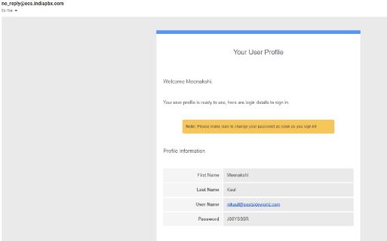

**CUSTOMER REGISTRATION EMAIL :**

Congratulations on signing up for the SMART vPBX service. You should have received an email.

**SIGN INTO YOUR ACCOUNT**

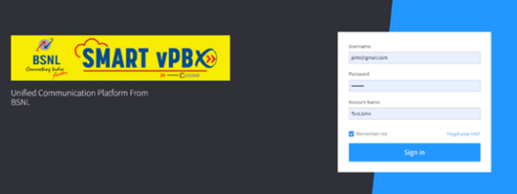

1. Go to <https://ecs.bharatcpbx.com/>
2. A landing page similar to the one alongside will appear.
3. Login with the credentials received in the mail (as shown above).
4. Your account name will be the same as mentioned in the customer registration email (example ‘TestMeenakshi’ as shown in below screenshot)
5. Graphical user interface, text, application

   Description automatically generatedEnter Username
6. Enter Password
7. Enter Account Name
8. Check ‘remember me’ (If you don't want to enter your credentials manually every time you enter)
9. **Click Sign In**

**YOUR PERSONALISED DASHBOARD**

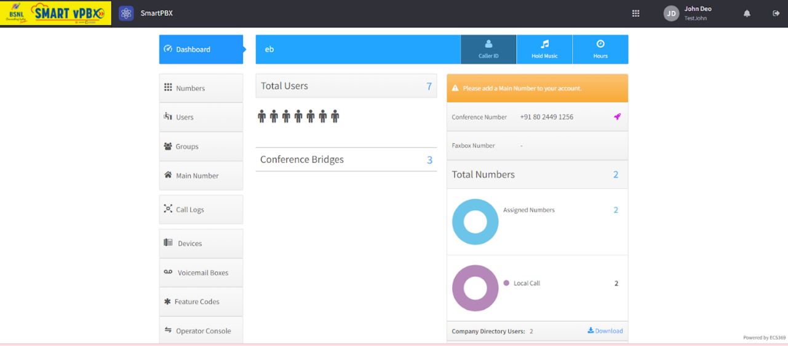

Configure your employee directory

Displays Numbers available from purchase Number allocation status e.g. DID allocation, Conference bridge allocation

**Click here for the following**

1. Company greeting
2. Allocation of number for DID,
3. Conference
4. Office hours (24hr open or timing for each day of week)
5. Holiday scheduling,
6. Incoming call handling,
7. Conference number configuration
8. transcription to mail.

This is your company’s number

**CREATING & CONFIGURING YOUR CUSTOMISED COMPANY GREETING**

Using the Smart VPBX services you can configure and customise your company greeting.

Greeting via Text to Speech or Media upload, Call recording, Next action if call not answered, Sequential or parallel ringing with timer, Caller id pretend for outgoing calls, allow call forward for call forwarding to next user or extension, Music on hold

**CONFIGURATION OF YOUR EMPLOYEES**

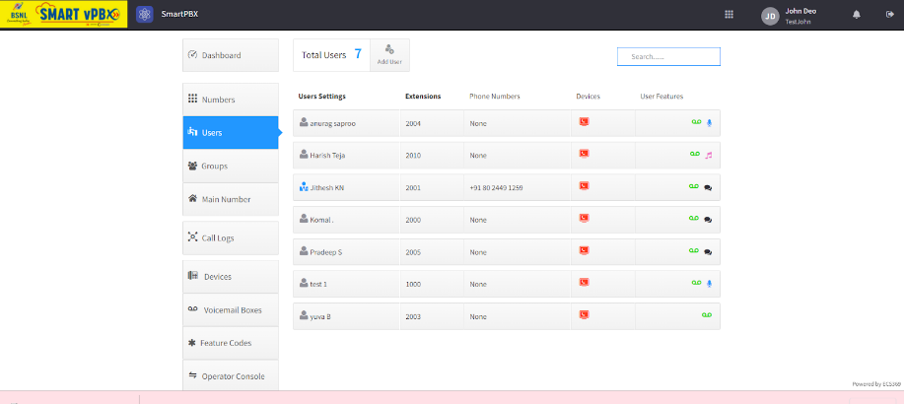

User search

Additional features

Devices associated

Extension number

Associated Cell Phone #. Edit as per company requirements

**MANAGE YOUR ENTERPRISE TASKS:**

1. Create a user with Name, Email, Extension number, Cell phone number and Password.
2. Send information via email to user. Add user to company directory.
3. User Privileges : Feature switch for all users for following features :

Call forwarding, Hot Desking, Conference bridge, Call recording, Music on hold, Do Not Disturb, Find me Follow me with sequential and parallel ringing options, Voicemail box.

1. For adding a phone number here, contact Super Admin.

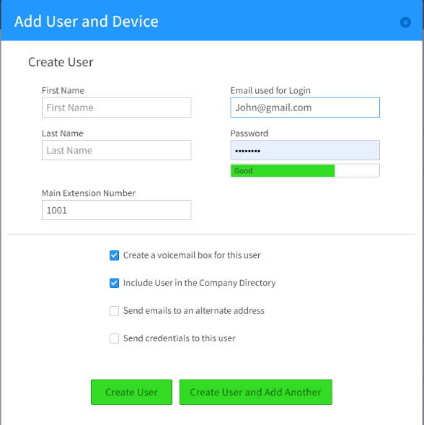

**ADDING AN EXTNSION**

On adding User, the extension is automatically generated. We can change the extension as per your requirement.

Autogenerated Extension is generated while creating User

Click on checkbox to send email to user for his credentials to login

**CONFIGURING GROUPS**

Display groups with information like extension number, features enabled, ‘DID’ number associated, and number of members in group.

Create group with information like Group Name, available users for selection and selected users

**DEVICES**

1. A screenshot of a computer

   Description automatically generated with medium confidenceDisplay list of created devices with the name, allocation, configuration parameters and enable/disable switch
2. Create following types of devices with relevant parameters, codec selection and restriction

a**.      SIP PHONE**

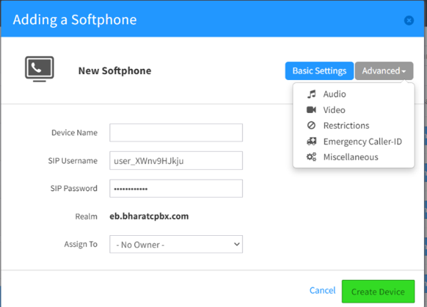b.      **Soft Phone**

* Click on Add Device
* Select Soft Phone
* Enter your Device Name, Your Sip Username, Sip Password and Assign To and click create Device

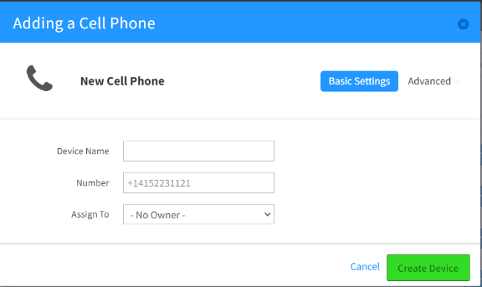c.      **Cell phone PSTN**

* Click on Add Device
* Select Cell Phone
* Enter your Device Name, Phone Number and Assign TO and click create Device

**d. Landline PSTN**

**e. ATA**

**f.    SIP URI**

**g.   Desk top APP**

**h. Mobile APP**

**EDITING A DEVICE**

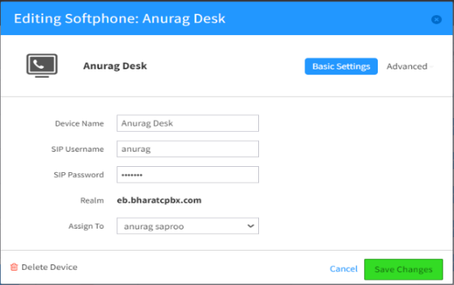 User can change the Device name, Sip Username,

password and Assign-To on Edit Softphone.

Under Advance option, user will have the option to change audio, video settings, Restrictions settings like Toll free number, allowing Local, International calls, Emergency caller-id and miscellaneous settings like allow Ignore Completed Elsewhere, Notify when unregistered etc.

User can delete the device also.

These are the basic steps to be followed for customer registration, creating users, groups and setting devices for users. For further queries and/or assistance please feel free to contact our customer care centre at [support@eastsideworld.com](mailto:support@eastsideworld.com)